K.R. MANGALAM UNIVERSITY
COURSE NAME = Computer Science Fundamentals and Carrer Pathways
COURSE CODE = ETCCCP105

Assignment Number 04= Tools for Programming, Learning, and Collaboration
Assignment Title = Build & Document a Mini Project Using
GitHub and VS Code
SUBMITTED BY: SUBMITTED TO:

NAME = LUCKY PANNU Mr .Feroz Ahmed ROLL NO = 2501410072 PROGRAMME = B.TECH CSE (cybersecurity) SEM = 1

SECTION = A

1. Step 1 – Project Selection and Setup
For this assignment, the selected mini project is the *Number Guessing Game* developed in Python. The objective of this project is to generate a random number which the user must guess based on hints provided by the program. The project was created using Visual Studio Code, managed through Git version control, and hosted on GitHub.

2. Step 2 – Development Tools Usage
Throughout the creation of this project, multiple Git commands were used to track changes, commit updates, and push the project to GitHub. Visual Studio Code served as the primary development environment for writing, testing, and editing the Python code.
Git commands used:
- Git remote add origin
You can check which repository you are working in with git remote -v
- git init – Initialize the repository
Git init is used to initialize a local repository on your machine locally for tracking any changes to the file while not connected to the internet or to save important commits and handle version control on your machine without any issues
- git add <file name> – Stage changes
Git add <file name> is used to add changes or save them on your local repository
- git commit -m "message" – Commit changes
This saves the complete code to the local machine and makes it a like version you can always go back to and edit form there only
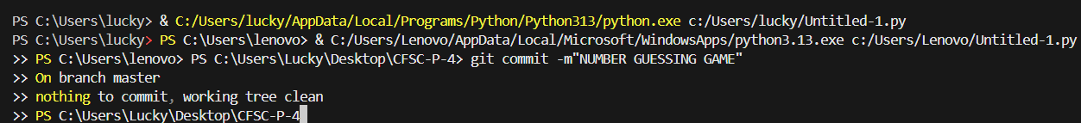
- git push origin main – Push the project to GitHub
This is used to push the project to the your github profile online
3. important commits made throughout the repository :
From initial commits . which is a commit that is made when you intialize your repo for the first time .
Other comments specify what has been fixed while doing every commit to remember what was fixed or added and deleted . this helps us in knowing which commit we made , why we made it and why its important to keep track of each and every commit .

4. Step 3 – Documentation and Repository Structure
The GitHub repository contains organized documentation and follows a clean structure. A `.gitignore` file is included to prevent unnecessary files from being tracked. A `README.md` file is added to explain the project details, instructions on running the code, and features.
Additional markdown documentation is also included for clarity.
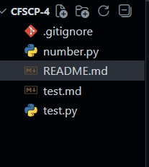
Repository Structure:
- number.py – Main program file
- README.md – Project documentation
- test.md – Local testing file (ignored)
- test.py – Temporary test file (ignored)
- .gitignore – Ignore rules for unnecessary files

5. Mini Project: Number Guessing Game (Python)
The Number Guessing Game is a simple Python console-based project where the computer generates a random number, and the user attempts to guess it. The program provides hints to guide the user towards the correct answer.

5.1 Features of the Game
- Random number generation
- Hint system (High / Low)
- Input validation to avoid invalid entries
- Clean and readable code
- Beginner-friendly logic

5.2 Code Overview
The code uses Python's built-in `random` module to generate a number. The user inputs their guess, and the program checks whether it is higher or lower than the target number. This loop continues until the correct number is guessed. The code is commented and structured for easy understanding.

6. Development Process
The development began by creating a new folder in Visual Studio Code and writing the initial number guessing logic. After the game was tested and verified, Git was initialized using `git init`. Changes were tracked and improved through multiple meaningful commits. Finally, the project was pushed to GitHub using remote repository commands.

7. Future Improvements
Several enhancements can be added to improve the game, such as difficulty levels, attempt counters, GUI support using Tkinter, score tracking, and sound effects. These additions would make the game more interactive and appealing.

8. Conclusion
This assignment helped in understanding the complete workflow of software
development—from coding and version control to documentation and publishing on GitHub. The hands-on experience gained through this project is essential for learning professional software development practices.

